**CENTRIFUGAL EXHAUST FANS:**

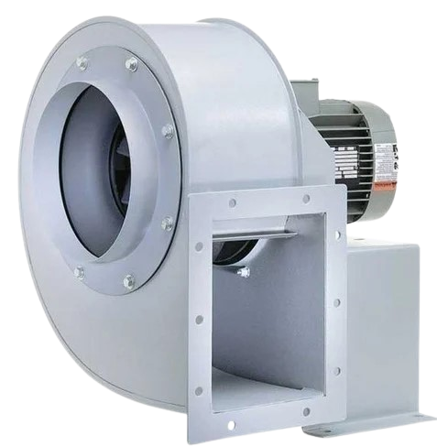

**Price: 5,900.00**

The Centrifugal Exhaust Fan is a high-performance ventilation solution, designed to efficiently remove large volumes of air, moisture, and pollutants from industrial, commercial, and residential spaces. With its robust centrifugal design and powerful motor, this fan delivers exceptional airflow capacity, making it ideal for applications requiring high-pressure ventilation, such as factories, warehouses, and laboratories. Its durable construction, corrosion-resistant coating, and easy installation ensure reliable performance and low maintenance requirements.

**Key features of centrifugal exhaust fans include:**

* **High Airflow Capacity:** Moves large volumes of air efficiently, ideal for larger spaces.
* **Strong Performance:** Provides powerful ventilation for heavy-duty applications.
* **Durable Construction:** Made with robust, corrosion-resistant materials for long-lasting use.
* **Quiet Operation:** Operates with minimal noise, even at high speeds.
* **Energy Efficient:** Consumes less power while maintaining optimal performance.
* **Versatile Application:** Suitable for industrial, commercial, and residential use.
* **Compact Design: Space-saving design for easy installation in confined areas.**